Question 1
Create a NumPy array containing the integers from 1 to 20.
Perform the following operations:
1. Display the array.
2. Find the shape of the array.
3. Find the maximum and minimum values.
4. Calculate the mean and standard deviation.
5. Reshape the array into a 4 × 5 matrix.
6. Display the second row of the matrix.
7. Display the third column of the matrix.

Code :

# question 1
import numpy as np
array = np.arange(1,21)
# Display the array
print("Array :" ,array)
# Find the shape of the array
print("Shape :" ,array.shape)
# Find the maximum and minimum values
print("Minimum :",min(array))
print("Maximum :", max(array))

# Mean and standard deviation
print("Mean :",np.mean(array))
print("Standard deviation : ",np.std(array))
# Reshape into 4*5 matrix
matrix = array.reshape(4,5)
print("Matrix :",matrix)
# Display second row
row = matrix[1]
print("Second row :",row)
# Display 3rd column
col = matrix[:,2]
print("Third column :",col)

Output :

Question 2
Create two NumPy arrays: A = [10, 20, 30, 40, 50] B = [5, 10, 15, 20, 25]
Perform:
1. Addition of A and B.
2. Subtraction of B from A.
3. Element-wise multiplication.
4. Element-wise division.
5. Find the sum of all elements in A.

Code :

# question 2
import numpy as np
a = np.array([10,20,30,40,50])
b = np.array([5,10,15,20,25])
# addition of a and b
print("Addition :",a+b)
# sub of a and b
print("Subtraction :",a-b)
# multiplication
print("Multiplication :",a*b)
#division
print("Division : ",a/b)
#Sum of elements in a
print("Sum :",sum(a))

Question 3
Create a DataFrame using the following student data:
Roll No Name Marks
101 Ravi 85
102 Priya 92
103 Kiran 78
104 Anu 88
Perform the following operations:
1. Display the DataFrame.
2. Display the first three records.
3. Find the average marks.
4. Find the student with the highest marks.
5. Find the student with the lowest marks.
6. Add a new column called "Grade" using:
o A for Marks ≥ 90
o B for Marks between 80 and 89
o C for Marks < 80

Code :

# question 3
import pandas as pd
data ={
"Roll No" : [101,102,103,104,105],
"Name" : ["Ravi","Priya","Kiran","Anu","Sita"],
"Marks" : [85,92,78,88,95]
}
df = pd.DataFrame(data)
# display df
print(df)
# Display 1st 3 records
print("First three records :")
print(df.head(3))
# Average marks
print("Average marks :",df["Marks"].mean())
# Highest marks
highest = df.loc[df["Marks"].idxmax()]
print("Student with highest marks:")
print(highest)
#lowest marks
lowest = df.loc[df["Marks"].idxmin()]
print("Student with lowest marks:")
print(lowest)
# add col grade
df["Grade"] = df["Marks"].apply(
lambda x: "A" if x>= 90 else "B" if x>=80 else "C"
)
print(df)

Question 4
Create a DataFrame containing the following information:
Product Price Quantity
Laptop 50000 10
Mouse 500 50
Keyboard 1200 30
Monitor 10000 15
Perform:
1. Calculate the total value of each product using: Total Value = Price × Quantity
2. Add the Total Value column.
3. Find the product with the highest total value.
4. Calculate the overall inventory value.

Code :

# question 4
import pandas as pd

data = {
"Product" : ["Laptop","Mouse","Keyboard","Monitor"],
"Price" : [50000,500,1200,10000],
"Quantity" : [10,50,30,15]
}
df = pd.DataFrame(data)
#Value
df["Total Value"] = df["Price"]*df["Quantity"]
print(df)
#Highest total value
highest = df.loc[df["Total Value"].idxmax()]
print("Highest product total value:")
print(highest)
#Overall inventory value
overall_value = df["Total Value"].sum()
print("Overall inventory value:",overall_value)

Output :

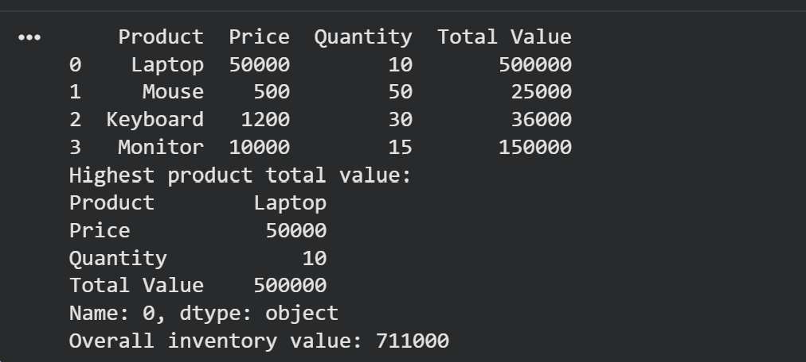

Code :
# question 5
import pandas as pd
from sklearn.datasets import load_iris

iris = load_iris()

df = pd.DataFrame(iris.data,columns=iris.feature_names)

df["Class"] =iris.target

print(df)

# First 5 records
print("First five records:")
print(df.head())

# Rows and columns
print("Rows and Columns :",df.shape)

# Column names
print("Columns:",df.columns)

# missing values
print(df.isnull().sum())
#summary statistics
print(df.describe())
# Samploe in class
print(df["Class"].value_counts())

